AUGUST 2022
Hello from the Sun City of El Paso and its sister city, Juarez, Mexico. God is moving and working and we thank Him for his goodness! God has re-ignited a passion in our pastors and church leaders, and they are setting off a Revival in their communities. In the first 6 months of 2022, we had a total of 6 baptisms and 90 professions of faith through our churches. Praise the Lord!
We thank God for the opportunity he gave us to minister to the immigrants with shelter, food, and spiritual nourishment since 2019. Many of them came to know the Lord while they were with us. As of July, we are no longer hosting immigrants. We are praying for the single mothers with children, and widows, that God will be sending us so that we can resume the use of the Mercy Homes to minister to them once again.

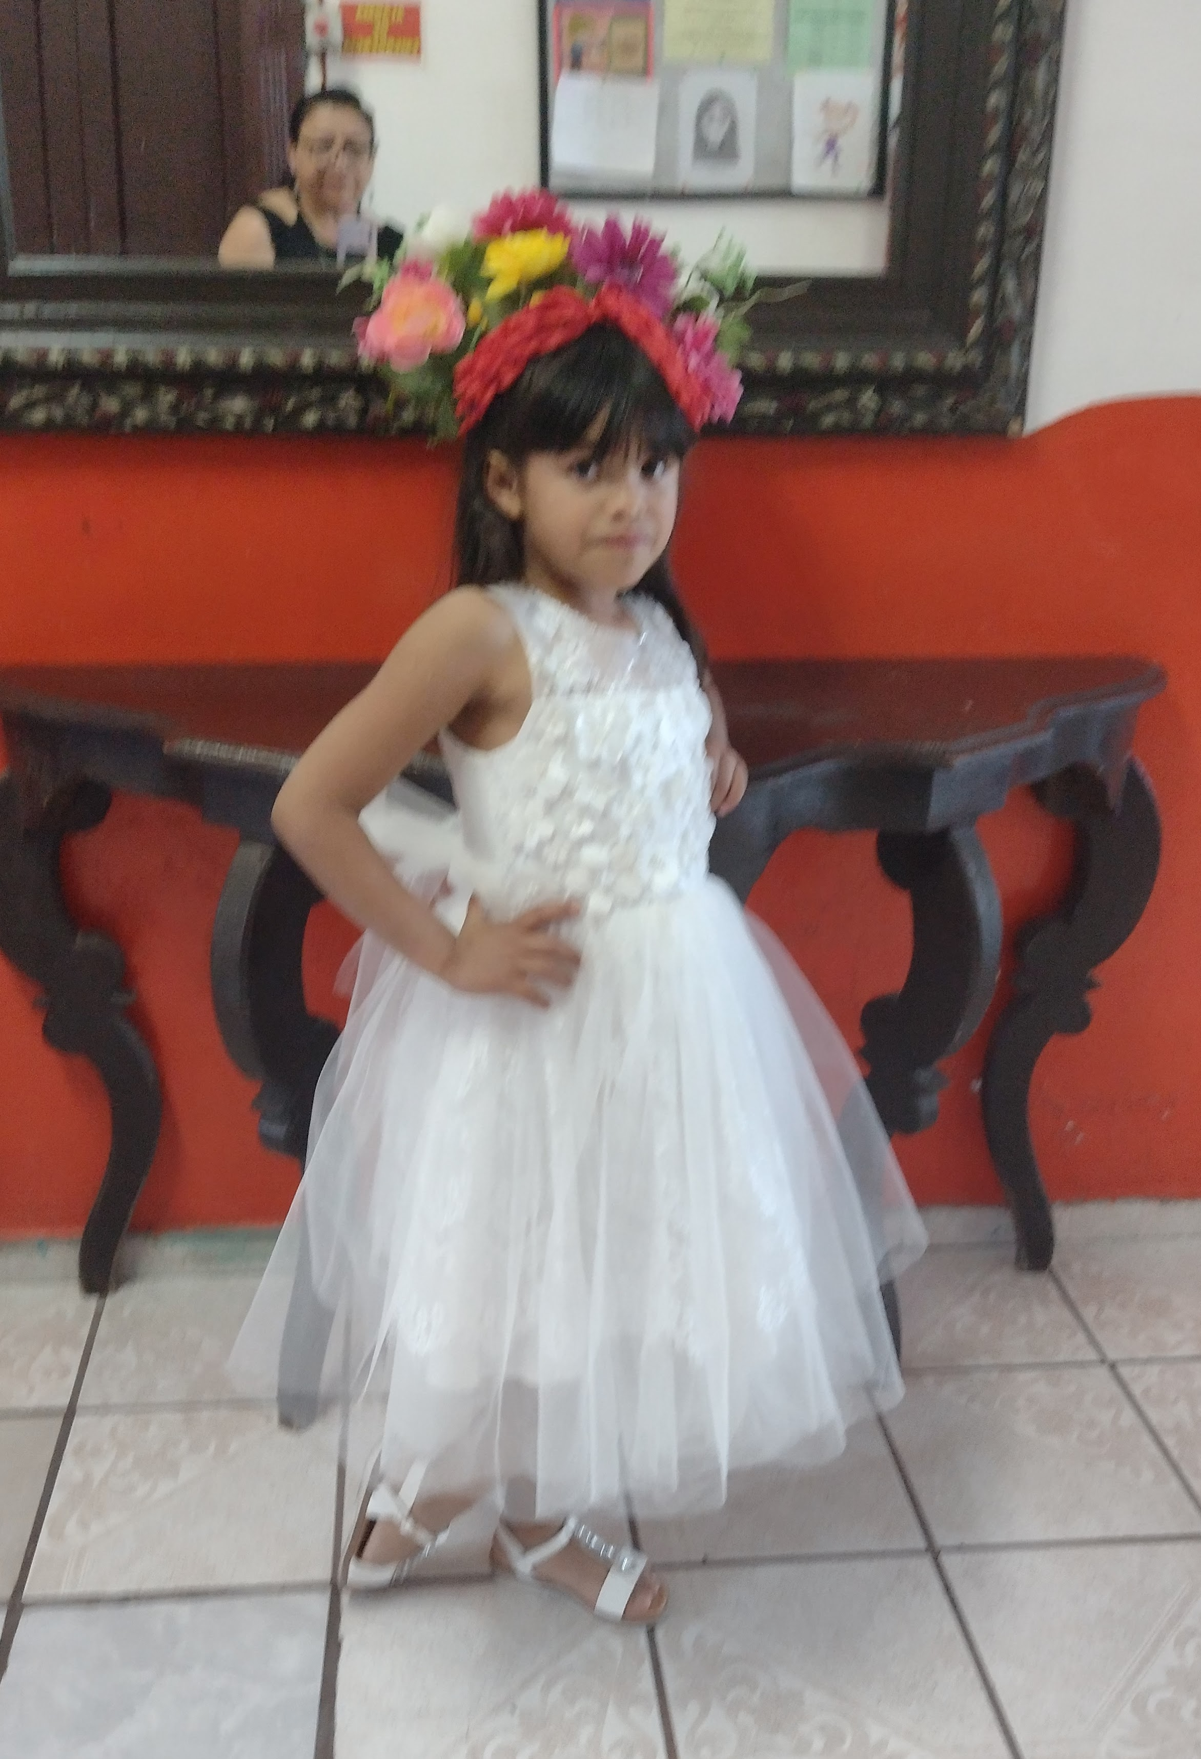
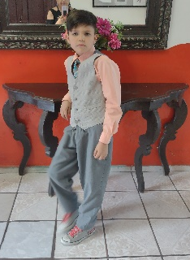
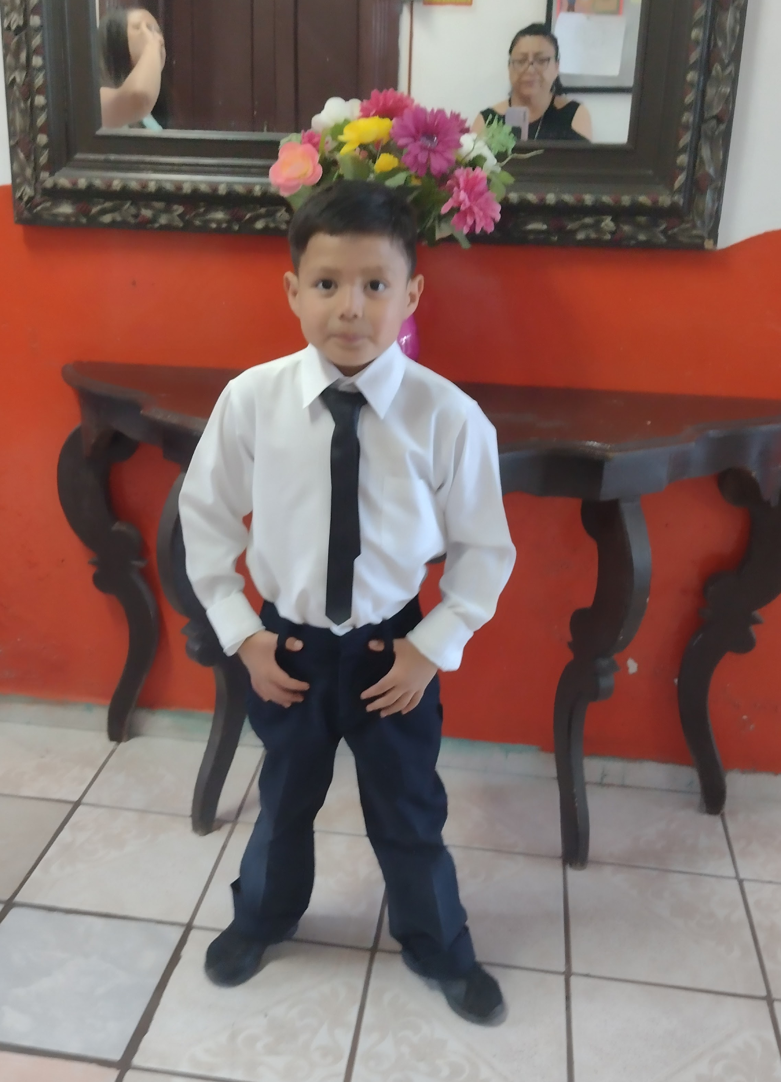
Are

These 3 little ones children came to us at Casa de Esperanza in October 2021 due to having been abandoned by their mother who is a drug user. Their father has been missing for many years so he has been presumed dead. Their maternal grandmother is their legal guardian, and she works cleaning houses to support the children. She has problems with her knees and has difficulty standing and

walking most days, so working is very hard for her. The children had not been attending school until they arrived with us. They have some behavioral problems that are being worked on with our psychologist. When the children arrived, the eldest boy was very angry and upset and the younger two kids were sad and fearful. Now, the children are happy, and love being there with us. Their grandma comes to visit them during the week and will take them home with her when she is feeling well.
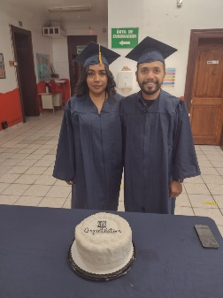
We had 2 students graduate in May from the Bible Institute. They are husband and wife and serve the Lord together assisting the pastor at their church. God is blessing the church where they are serving and we thank the Lord for the honor of preparing them to serve Him.

We are getting ready for the children at Casa de Esperanza to start school later this month. We are grateful to Primera Iglesia Bautista Hispana in Carrollton, Texas, who donated backpacks full of school supplies for all the children, and a huge thank you to the Jaramillo family for delivering them to us!!
It may seem a bit early, but we are asking for prayers for our Thanksgiving Outreach. We are already in the planning stages. Our prayer is that the violence in Juarez will continue its downward trend and we will be able to have volunteer families and church groups come to help us this year.
Thank you for your prayers and support. We are grateful for each one of you partnering with us in ministry. God bless you and your family!

