Dear Ministry Partner,
APRIL 2022
We have hit the ground running in 2022! We are still in the middle of the COVID-19 pandemic and while things may be relaxed here in the United States, they are quite different in Mexico: facemasks are still mandated, temperature screenings are required upon entry into any public place, and the children are attending school on a hybrid model—2 days on campus and 3 days virtually via Zoom. Despite the looming threat of a public health illness, we praise God as He has protected our staff, children, volunteers, and all those we minister to in the colonias, Juarez and in El Paso. For the last 15 months, we have all been healthy and well in Jesus’ name!
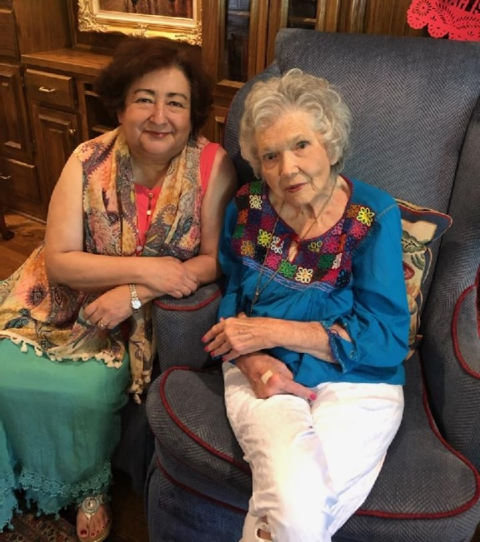
We have been working hard at Hands of Luke. The medical team is staying busy at the 3 clinics seeing about 58 patients a week. Our 5 churches continue growing as they hold worship service on Sundays, as well as prayer meetings and bible studies throughout the week. The Bible Institute students meet twice a week and are nearing the end of this semester. At all our facilities, we are actively feeding 1,500-1,700 children and adults each day. We Praise the Lord for His provision of food, staff and volunteers. We are so blessed to share our Heavenly Father’s love with each of these souls we encounter daily!
On January 23, 2022, we lost a beautiful servant of the Lord by the name of Sarah Jeannine Landes, from Austin, Texas. Sarah went home to be with the Lord after 92 years of faithfully serving Him.

Dr. Marco and I met Sarah over 42 years ago and she and her family, have become our family. For over 40 years, she came to serve in Juarez and brought many mission groups throughout the years. She served in various ways at Hands of Luke since we first began. She would come with a group of women to host an annual women’s Conference for the ladies in Mexico and El Paso. Every year, she collected toys, clothes, and donations for the children at La Esperanza Children’s Home and for anyone in need. Later, she began collecting even more items to place in the Christmas Outreach gift bags for the children in Mexico. Her last mission was this past December when she sent thousands of items for the Christmas gift bags (toys, candy, etc). She was loved so much by me and Marco, our family, and her Hands of Luke family. Our beautiful and dearly missed Sarah, “Many women do noble things, but you surpass them all.”
Proverbs 29:31
Carmen Samaniego
and
Sarah Landes

