HANDS OF LUKE MEDICAL MINISTRIES
October 2023
Hello Ministry Partners,
Fall is upon us! The children at the Children’s Home are off to a great start this new school year. Huge THANK YOU to Primera Iglesia Bautista Hispana in Carrollton, TX, for providing backpacks filled with supplies to all the children! Thank you for blessing these little ones.
We are blessed to continue ministering to the underprivileged through the Nutritional Centers, Mercy Homes, Medical Clinics, Bible Institute and Churches. God is working through your faithful prayers and support! We are grateful for YOU!!
THANKSGIVING & CHRISTMAS OUTREACH UPDATES

- Thanksgiving Outreach: we have churches and individuals that have helped us in the past with food items. We are trusting in God that they will help us again this year. We do need funds to help purchase the paper goods (cups, plates, napkins, plasticware) and extra turkeys needed. Our goal this year is to serve 20,000 meals all for God’s honor and glory.
- Christmas Outreach: Right now, our biggest need is items to fill the gift bags. Our goal is to make
5,500 bags for children living in impoverished areas. The items needed are:
- Small toys
*If you are interested in volunteering to help fill the bags, we’d love to have you! It will all take place in El Paso, Texas, December 6th - 8th . Please call or email us for more information.
- Hard candy
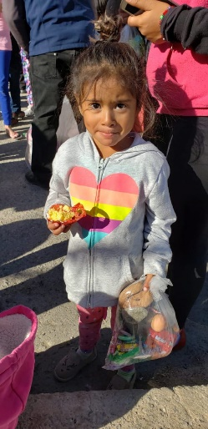
- Socks (boy & girl)
- Undergarments (boy & girl)
- Travel size toothpaste & toothbrush
- Spanish bible tracts for children
- Financial gift to purchase items
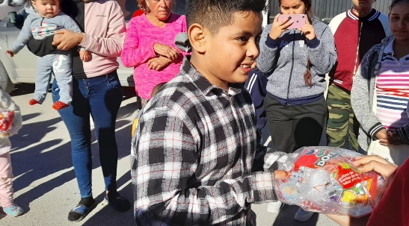
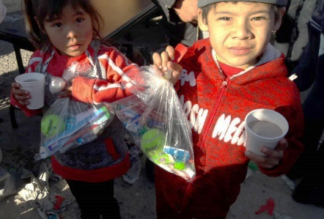

WAYS TO GIVE:
- Go to www.handsofluke,org and click the DONATE button
- Text HANDSOFLUKE to 707070 on your mobile phone
- Mail a check to: Hands of Luke
11184 Voyager Cove Dr.
El Paso, TX 79936
- Email us at: handsoflukeministries@gmail.com
- Call us at: (915) 637-1674

FAMILY UPDATE: Laura’s husband, Brian, went to be with the Lord on July 29th, 2023. While we are sad and miss him tremendously, we are comforted in knowing that Brian is now pain-free, healthy, and rejoicing with our Savior. Please continue praying for our family as we grieve.

Thank you!
God bless you!
Family Prayer Requests Update:
In sad news, Laura’s husband Brian, went to be with the Lord on July 29, 2023. We are comforted by knowing that he has been made new and is rejoicing in heaven with our Savior. Please pray for our family as we continue grieving.
In happy news, Brian and Laura’s first grandchild was born on August 7th. Mylah Avery Squires is a beautiful blessing and has brought us great joy in the midst of our sorrow.

