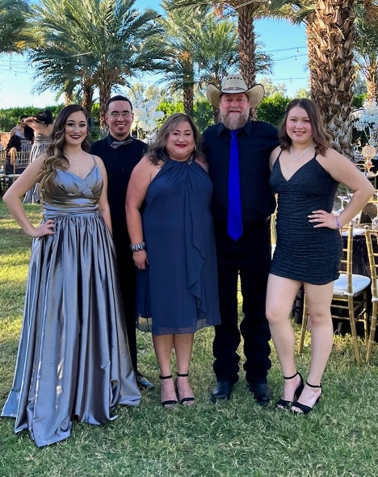endless

**In His Service,**

**Laura and Carmen**

**Hands of Luke Staff**

**Lakeside Baptist Church**

**265 George Orr Dr.**

**El Paso, TX 79915**

Since the second week of October, there have been hundreds of migrants from Venezuela in Juarez that are living on the street near the bridge that crosses into the US. They were denied entry or were expelled from the US. We began ministering to them by taking them burritos. They’re in dire need of warm clothes and blankets for all ages, as the outdoor temperatures began dropping last week. We’ve been collecting and have still fallen short. If you’d like to send warm items, please send to:

Thank you for all you do!! God bless you!

**The Mitchell Family**

**HANDS OF LUKE MEDICAL MINISTRIES - November 2022**

Hello Ministry Partners,

My name is Laura Samaniego Mitchell. I am the daughter of Dr. Marco and Carmen Samaniego. I have been a part of Hands of Luke Medical Ministries in various roles since we first opened the doors 34 years ago. I am excited to announce the Lord has called me to full-time ministry with Hands of Luke! I have been a Registered Nurse for 20 years with ER/Trauma, and school nursing experience. My husband Brian and I have been married for almost 27 years and we have 3 adult children, Andrew, Miranda, and Samantha who married our son-in-law Noah this past March. After much prayer, mom (Carmen) is transitioning to a semi-retirement mode. This past July, our Board of Trustees appointed me as Chief Operating Officer and mom will remain as Director. We are working closely together to make the transition as smooth as possible. Mom calls it "semi-retirement" as she wants to remain active in the ministry but in a less active role. I am extremely grateful that God has granted me the honor and privilege of following in my parents' footsteps! Please pray for me and my family and all of us at Hands of Luke as we serve our Lord and Savior. I am so excited for what God has in store for us at HOL! We are working on many new goals. Our prayer is that in 2023, it will be safe enough to start inviting groups to come do mission work, construction projects, medical clinics, VBS, and to volunteer with Outreaches and other projects.

We are grateful to God for each of you! Through your endless prayers and support, we help those in need with shelter, food, clothing, medical care and other needs that may arise. Most of all, we share with them about God’s wonderful love and how He sent His only Son Jesus to save us all. Thank you for partnering with us!

We are in “Full Prep Mode” for our **Thanksgiving Outreach** which will take place Nov. 24th-27th. Our goal is to feed **20,000 hungry souls** in Jesus’ name! We’re busy buying turkeys, cooking and freezing them. We’re buying paper goods, aluminum trays, foil paper, etc. We are still in need of purchasing some food and necessary items.

While Christmas only comes once a year, we work towards the **Christmas Outreach** all year long collecting the items we put inside the gift bags. Our goal this year is to make gift bags for **5,500 impoverished children** in Juarez. We will be making the bags Dec.8th-10th. Please pray for the safety, health and energy for all the volunteers and staff involved in both these Outreaches.

With the recent inflation, it’s getting harder to purchase the items we use for these Outreaches but we know our Lord will provide. Our biggest needs right now are turkeys, large cans of vegetables and paper goods for Thanksgiving; for the Christmas bags, individually wrapped candy, and small toys. Thank you for interceding for our needs!