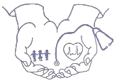
Hands of Luke Medical Ministries MARCH 2023

We are extremely grateful to report that this year we will celebrate our 35th ANNIVERSARY of ministry, ALL glory and honor to God! It has been a blessing to see how our Lord has used your prayers and support to make a difference in the lives of so many underprivileged children and adults. Your generosity has helped countless individuals experience God’s grace, love, healing power and ultimate salvation since 1988.

In 2022, the Lord allowed us to use your gifts to minister in the following ways:

208 CHILDREN lived in Casa de Esperanza Children’s Home
2000 CHILDREN were fed DAILY through the Nutritional Centers
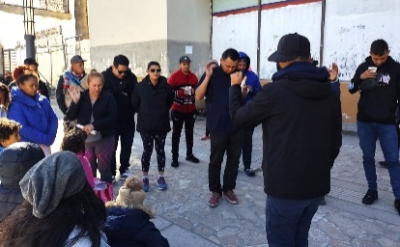
5 CHURCHES were supported
5,583 PATIENTS received medical care
380 WOMEN & CHILDREN lived in the Mercy Homes
10 STUDENTS attended the Bible Institute with 2 GRADUATES
20,200 PEOPLE were ministered to during the Thanksgiving Outreach
6,500 CHILDREN were ministered to during the Christmas Outreach
1,821 people ACCEPTED JESUS CHRIST as their Lord and Savior
Your prayers and support changed 38,303 lives in the El Paso/Juarez community!

We are excited to see what God will do in 2023 through Hands of Luke and your continued partnership, love and prayers. God bless you!
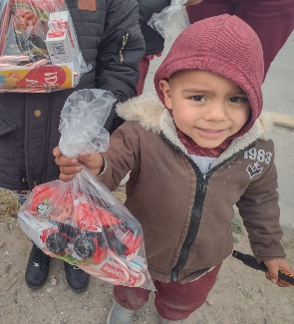
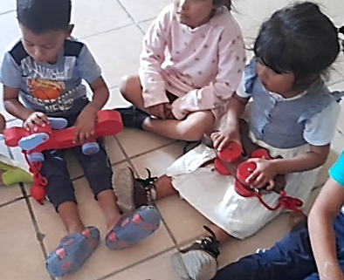
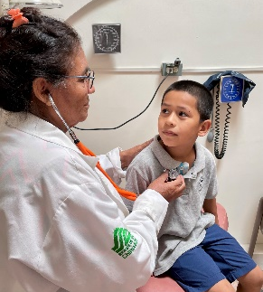
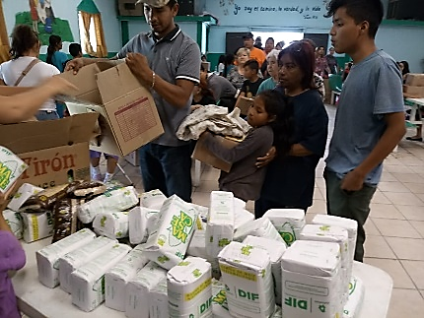
WWW.HANDSOFLUKE.ORG

