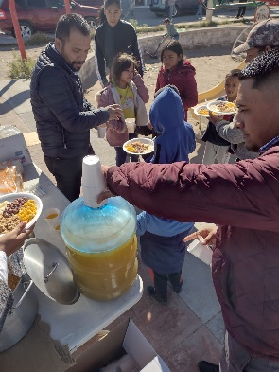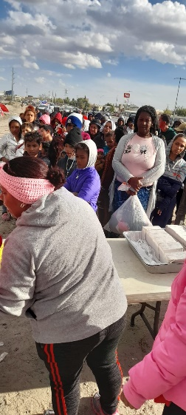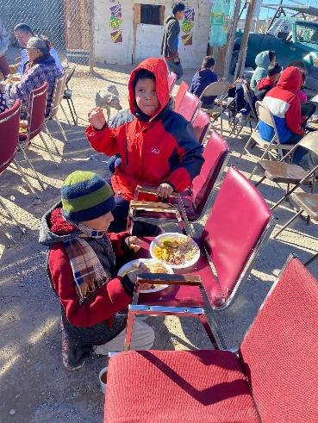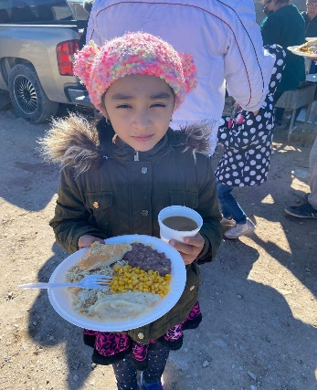

From all of us at Hands of Luke, we wish you a very Merry Christmas and a Happy New Year!

Dear Ministry Partners,

What a mighty God we serve! Our **Thanksgiving Outreach** was a huge success!! We are blessed to report the following praise report.

* 20, 200 meals were served
* 737 people accepted Jesus as their Lord and Savior

**PRAISE THE LORD!!!** These salvations, the seeds that are planted, and seeing the smiles on their faces make all our efforts worth it. God is so so good!

**Christmas Outreach Update:**

We made 5,000 gift bags and will be delivering them to the children on Dec. 16th & 17th. We are so excited to see their little faces light up when they receive their gift bags.

A **HUGE THANK YOU** to all of you for serving alongside us by collecting food/items for these outreaches, delivering those items to us, volunteering your time to help us with these events, your financial gifts, sending us warm blankets and clothes for the immigrants, and most of all, for lifting us up to our Heavenly Father!

**HANDS OF LUKE MEDICAL MINISTRIES-December 2022**